Topic – 11

1. Bellman-Ford Algorithm

Aim
To implement the Bellman-Ford algorithm to find the shortest distance from a source vertex to all other vertices in a weighted directed graph and detect negative weight cycles.

Algorithm
- Initialize the distance of the source vertex as 0 and all other vertices as infinity.
- Relax all edges V-1 times, where V is the number of vertices.
- For every edge (u, v, weight), update the distance if a shorter path is found.
- Perform one additional relaxation of all edges.
- If any distance can still be reduced, a negative weight cycle exists.
- Otherwise, print the shortest distances.

Program:

# Bellman-Ford Algorithm

def bellman_ford(vertices, edges, source):
# Step 1: Initialize distances
distance = [float('inf')] * vertices
distance[source] = 0

# Step 2: Relax all edges V-1 times
for _ in range(vertices - 1):
updated = False

for u, v, weight in edges:
if distance[u] != float('inf') and distance[u] + weight < distance[v]:
distance[v] = distance[u] + weight
updated = True

# Stop early if no update occurs
if not updated:
break

# Step 3: Check for negative weight cycle
for u, v, weight in edges:
if distance[u] != float('inf') and distance[u] + weight < distance[v]:
return None

return distance

# -------------------------------
# Example 1
# -------------------------------
vertices = 5

edges = [
(0, 1, -1),
(0, 2, 4),
(1, 2, 3),
(1, 3, 2),
(1, 4, 2),
(3, 2, 5),
(3, 1, 1),
(4, 3, -3)
]

source = 0

distance = bellman_ford(vertices, edges, source)

if distance is None:
print("Negative Weight Cycle Detected")
else:
print("Vertex Distance")
for i in range(vertices):
print(i, distance[i])

# -------------------------------
# Example 2
# -------------------------------
print("\nExample 2:")

vertices = 3

edges = [
(0, 1, 1),
(1, 2, -1),
(2, 0, -1)
]

source = 0

distance = bellman_ford(vertices, edges, source)

if distance is None:
print("Negative Weight Cycle Detected")
else:
print("Vertex Distance")
for i in range(vertices):
print(i, distance[i])

Output:
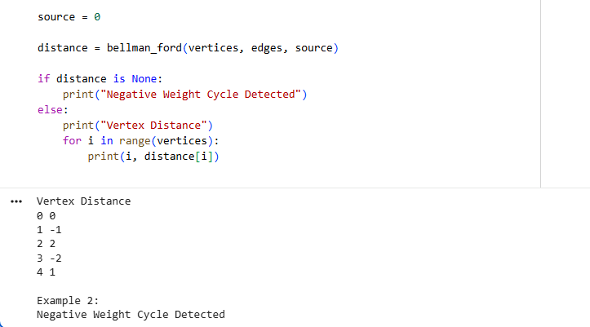

Result
The Bellman-Ford algorithm successfully finds the shortest paths from the source vertex and detects the presence of a negative weight cycle.
2. Floyd-Warshall Algorithm

Aim
To implement the Floyd-Warshall algorithm to find the shortest distances between every pair of vertices in a weighted graph.

Algorithm
- Initialize the distance matrix with the given graph.
- Set INF for pairs of vertices that have no direct edge.
- Select each vertex k as an intermediate vertex.
- For every pair (i, j), check whether the path through k is shorter:
dist[i][j] = min(dist[i][j], dist[i][k] + dist[k][j])
- Repeat this for all vertices.
- Print the resulting shortest-distance matrix.

Program:
INF = float('inf')
def floyd_warshall(graph):
n = len(graph)
dist = [row[:] for row in graph]
for k in range(n):
for i in range(n):
for j in range(n):
if dist[i][k] != INF and dist[k][j] != INF:
dist[i][j] = min(
dist[i][j],
dist[i][k] + dist[k][j]
)
return dist
def print_matrix(matrix):
for row in matrix:
print([
"INF" if value == INF else int(value)
for value in row
])
print("Example 1:")

graph1 = [
[0, 5, INF, 10],
[INF, 0, 3, INF],
[INF, INF, 0, 1],
[INF, INF, INF, 0]
]

result1 = floyd_warshall(graph1)
print_matrix(result1

graph2 = [
[0, 2, INF],
[INF, 0, 4],
[1, INF, 0]
]

result2 = floyd_warshall(graph2)
print_matrix(result2)

Output:
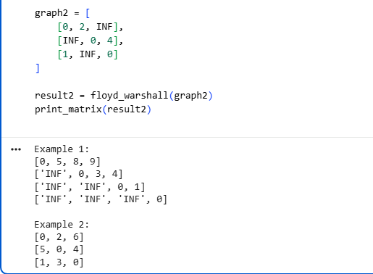

Result
The Floyd-Warshall algorithm successfully calculates the shortest distances between every pair of vertices for both given graphs.

3. Warshall's Algorithm

Aim
To find the transitive closure of a directed graph using Warshall's algorithm.

Algorithm
- Initialize the closure matrix with the adjacency matrix.
- Select each vertex k as an intermediate vertex.
- For every pair (i, j), check whether a path exists through k.
- Update closure[i][j].
- Repeat for all vertices.
- Print the transitive closure.

Algorithm:
def warshall(graph):
n = len(graph)
closure = [row[:] for row in graph]
for k in range(n):
for i in range(n):
for j in range(n):
closure[i][j] = closure[i][j] or (
closure[i][k] and closure[k][j]
)
return closure
def print_matrix(matrix):
for row in matrix:
print(row)
print("Example 1:")
graph1 = [
[0, 1, 0, 0],
[0, 0, 1, 0],
[0, 0, 0, 1],
[0, 0, 0, 0]
]
result1 = warshall(graph1)
print_matrix(result1)
print("\nExample 2:")
graph2 = [
[0, 1, 1],
[0, 0, 1],
[1, 0, 0]
]
result2 = warshall(graph2)
print_matrix(result2)

Output:
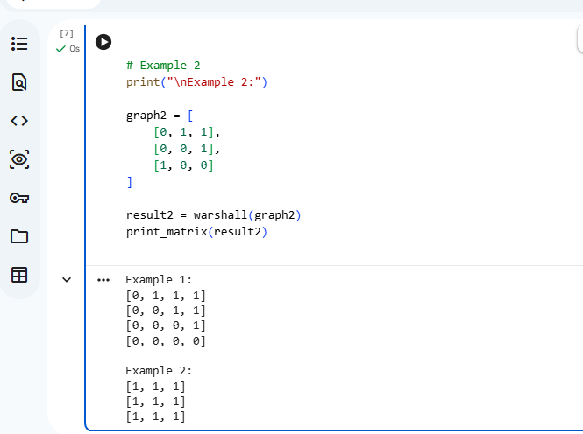

Result
The transitive closure of the given directed graphs was successfully obtained.

4. Find the City with the Smallest Number of Reachable Cities

Aim
To find the city that can reach the smallest number of other cities within a given distance threshold using Floyd-Warshall.

Algorithm
- Initialize the distance matrix.
- Store the edge weights.
- Apply Floyd-Warshall to find all-pairs shortest distances.
- For each city, count cities whose shortest distance is less than or equal to the threshold.
- Select the city with the minimum count.
- In case of a tie, select the city with the larger index.

Output:
INF = float('inf')
def find_city(n, edges, threshold):
dist = [[INF] * n for _ in range(n)]
for i in range(n):
dist[i][i] = 0
for u, v, w in edges:
dist[u][v] = w
dist[v][u] = w
for k in range(n):
for i in range(n):
for j in range(n):
if dist[i][k] != INF and dist[k][j] != INF:
dist[i][j] = min(
dist[i][j],
dist[i][k] + dist[k][j]
)
min_count = INF
answer = -1
for i in range(n):
count = 0
for j in range(n):
if i != j and dist[i][j] <= threshold:
count += 1
if count <= min_count:
min_count = count
answer = i
return answer
print("Example 1:")
n = 4
edges = [
[0, 1, 3],
[1, 2, 1],
[2, 3, 4],
[0, 3, 7]
]
threshold = 4

print(find_city(n, edges, threshold))
print("\nExample 2:")
n = 5
edges = [
[0, 1, 2],
[0, 4, 8],
[1, 2, 3],
[1, 4, 2],
[2, 3, 1],
[3, 4, 1]
]
threshold = 2
print(find_city(n, edges, threshold))

Output:

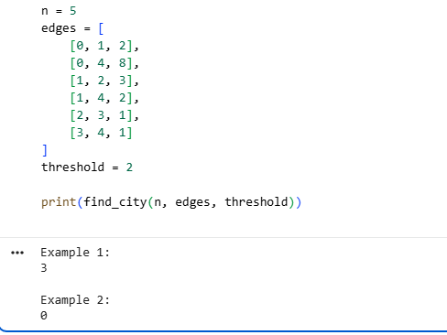

Result
The city with the smallest number of reachable cities was successfully determined.

5. Network Delay Time

Code

INF = float('inf')

def network_delay_time(times, n, k):
# Distance array
dist = [INF] * (n + 1)
dist[k] = 0

# Relax edges n-1 times
for _ in range(n - 1):
updated = False

for u, v, w in times:
if dist[u] != INF and dist[u] + w < dist[v]:
dist[v] = dist[u] + w
updated = True

if not updated:
break

# Find maximum distance
maximum = 0

for i in range(1, n + 1):
if dist[i] == INF:
return -1

maximum = max(maximum, dist[i])

return maximum

# Example 1
print("Example 1:")

times = [
[2, 1, 1],
[2, 3, 1],
[3, 4, 1]
]

n = 4
k = 2

print(network_delay_time(times, n, k))

# Example 2
print("\nExample 2:")

times = [
[1, 2, 1]
]

n = 2
k = 2

print(network_delay_time(times, n, k))

Output
Example 1:
2

Example 2:
-1

Aim
To find the minimum time required for a signal to reach all nodes using the Bellman-Ford algorithm.

Algorithm
- Initialize the source node distance as 0.
- Set all other distances to infinity.
- Relax all edges n-1 times.
- Find the maximum shortest distance.
- If any node remains unreachable, return -1.

Result
The network delay time was successfully calculated. If a node cannot be reached, the program returns -1.

6. Cheapest Flight Within K Stops

Python Code
Python
Run
# Cheapest Flight Within K Stops
# Using Bellman-Ford Algorithm

INF = float('inf')

def cheapest_flight(n, flights, src, dst, K):
# Initially, source has cost 0
dist = [INF] * n
dist[src] = 0

# At most K stops means at most K+1 flights
for _ in range(K + 1):

# Copy distances to avoid using more than
# K+1 flights in one iteration
new_dist = dist[:]

for u, v, cost in flights:
if dist[u] != INF:
new_dist[v] = min(
new_dist[v],
dist[u] + cost
)

dist = new_dist

if dist[dst] == INF:
return -1

return dist[dst]

# Example 1
print("Example 1:")

n = 4

flights = [
[0, 1, 100],
[1, 2, 100],
[2, 3, 100],
[0, 3, 500]
]

src = 0
dst = 3
K = 1

print(cheapest_flight(n, flights, src, dst, K))

# Example 2
print("\nExample 2:")

K = 2

print(cheapest_flight(n, flights, src, dst, K))

Output

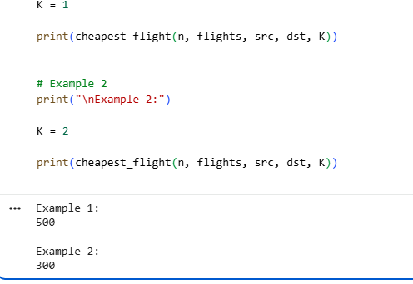

Aim
To find the minimum flight cost between a source and destination with at most K stops using the Bellman-Ford algorithm.

Algorithm
- Set the source distance to 0.
- Set all other distances to infinity.
- Perform K+1 relaxation rounds.
- Use a temporary array in each round.
- The destination distance gives the cheapest cost.
- Return -1 if the destination cannot be reached.

Result
The cheapest flight cost within the specified number of stops was successfully calculated.

7. Detect Negative Weight Cycle

Python Code
Python
Run
# Detect Negative Weight Cycle
# Using Bellman-Ford Algorithm

def has_negative_cycle(vertices, edges):

# Set all distances to 0.
# This allows detection of a negative cycle
# anywhere in the graph.
dist = [0] * vertices

# Relax edges V-1 times
for _ in range(vertices - 1):
for u, v, weight in edges:
if dist[u] + weight < dist[v]:
dist[v] = dist[u] + weight

# Check one more time
for u, v, weight in edges:
if dist[u] + weight < dist[v]:
return True

return False

# Example 1
print("Example 1:")

vertices = 4

edges = [
(0, 1, 1),
(1, 2, -1),
(2, 3, -1),
(3, 0, -1)
]

if has_negative_cycle(vertices, edges):
print("Negative Weight Cycle Exists")
else:
print("No Negative Weight Cycle")

# Example 2
print("\nExample 2:")

edges = [
(0, 1, 4),
(0, 2, 5),
(1, 2, -2),
(2, 3, 3)
]

if has_negative_cycle(vertices, edges):
print("Negative Weight Cycle Exists")
else:
print("No Negative Weight Cycle")

Output

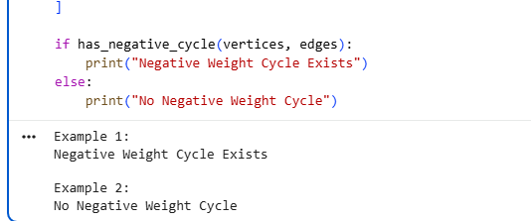Aim
To detect whether a weighted directed graph contains a negative weight cycle using Bellman-Ford.

Algorithm
- Initialize all distances to 0.
- Relax all edges V-1 times.
- Perform one additional relaxation.
- If any distance is updated, a negative weight cycle exists.
- Otherwise, no negative weight cycle exists.

Result
The program successfully detects the negative weight cycle in Example 1 and confirms that Example 2 has no negative weight cycle.

8. Determine Reachability Between Two Vertices

Python Code
Python
Run
# Determine Reachability Between Two Vertices
# Using Warshall's Algorithm

def warshall(graph):
n = len(graph)

closure = [row[:] for row in graph]

for k in range(n):
for i in range(n):
for j in range(n):
closure[i][j] = closure[i][j] or (
closure[i][k] and closure[k][j]
)

return closure

# Example 1
print("Example 1:")

graph1 = [
[0, 1, 0],
[0, 0, 1],
[0, 0, 0]
]

u = 0
v = 2

closure = warshall(graph1)

if closure[u][v]:
print("Path Exists")
else:
print("Path Does Not Exist")

# Example 2
print("\nExample 2:")

graph2 = [
[0, 1, 0],
[0, 0, 0],
[1, 0, 0]
]

u = 1
v = 2

closure = warshall(graph2)

if closure[u][v]:
print("Path Exists")
else:
print("Path Does Not Exist")

Output

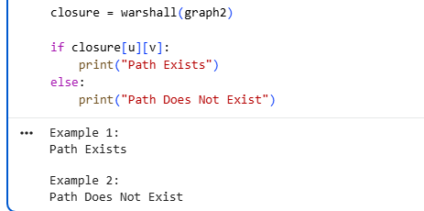Aim
To determine whether a path exists between two given vertices using Warshall's algorithm.

Algorithm
- Calculate the transitive closure using Warshall's algorithm.
- Access closure[u][v].
- If it is 1, a path exists.
- Otherwise, a path does not exist.

Result
The reachability between the specified vertices was successfully determined.

9. Count Reachable Vertices from a Source

Python Code
Python
Run
# Count Reachable Vertices from a Source
# Using Warshall's Algorithm

def warshall(graph):
n = len(graph)

closure = [row[:] for row in graph]

for k in range(n):
for i in range(n):
for j in range(n):
closure[i][j] = closure[i][j] or (
closure[i][k] and closure[k][j]
)

return closure

def count_reachable(graph, source):
closure = warshall(graph)

count = 0

for j in range(len(graph)):
if j != source and closure[source][j]:
count += 1

return count

# Example 1
print("Example 1:")

graph1 = [
[0, 1, 0, 0],
[0, 0, 1, 0],
[0, 0, 0, 1],
[0, 0, 0, 0]
]

source = 0

print(count_reachable(graph1, source))

# Example 2
print("\nExample 2:")

graph2 = [
[0, 1, 1],
[0, 0, 1],
[1, 0, 0]
]

source = 1

print(count_reachable(graph2, source))

Output

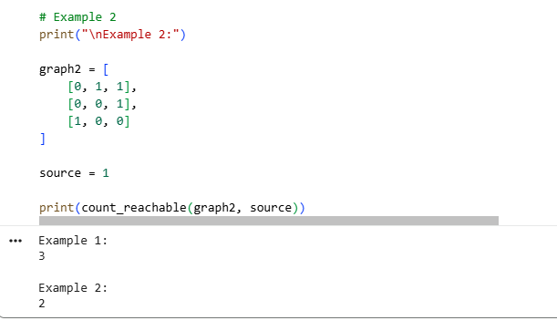Aim
To count the number of vertices reachable from a specified source using the transitive closure obtained by Warshall's algorithm.

Algorithm
- Compute the transitive closure.
- Select the row corresponding to the source vertex.
- Check every vertex reachable from the source.
- Do not count the source itself.
- Return the total count.

Result
The number of reachable vertices from the specified source was successfully calculated.

10. Find the Diameter of a Graph

Python Code
Python
Run
# Find the Diameter of a Graph
# Using Floyd-Warshall Algorithm

INF = float('inf')

def graph_diameter(graph):
n = len(graph)

# Copy graph
dist = [row[:] for row in graph]

# Floyd-Warshall Algorithm
for k in range(n):
for i in range(n):
for j in range(n):
if dist[i][k] != INF and dist[k][j] != INF:
dist[i][j] = min(
dist[i][j],
dist[i][k] + dist[k][j]
)

# Find maximum shortest-path distance
diameter = 0

for i in range(n):
for j in range(n):
if dist[i][j] != INF:
diameter = max(diameter, dist[i][j])

return diameter

# Example 1
print("Example 1:")

graph1 = [
[0, 2, INF],
[2, 0, 3],
[INF, 3, 0]
]

print(graph_diameter(graph1))

# Example 2
print("\nExample 2:")

graph2 = [
[0, 1, 4],
[1, 0, 2],
[4, 2, 0]
]

print(graph_diameter(graph2))

Output

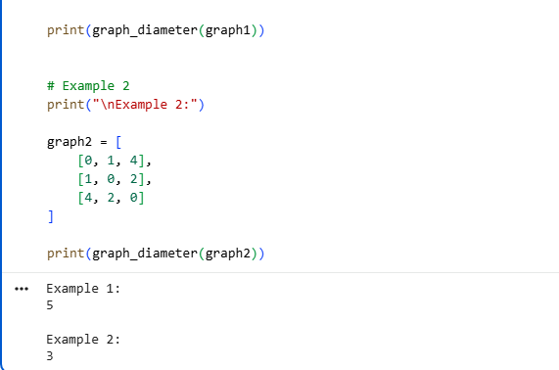Aim
To find the diameter of a weighted graph using the Floyd-Warshall algorithm.

Algorithm
- Initialize the distance matrix with the graph weights.
- Apply Floyd-Warshall to calculate shortest paths between all pairs.
- Examine all finite shortest-path distances.
- Find the maximum shortest-path distance.
- This maximum value is the graph's diameter.

Result
The diameter of the given graphs was successfully calculated as 5 for Example 1 and 3 for Example 2.

